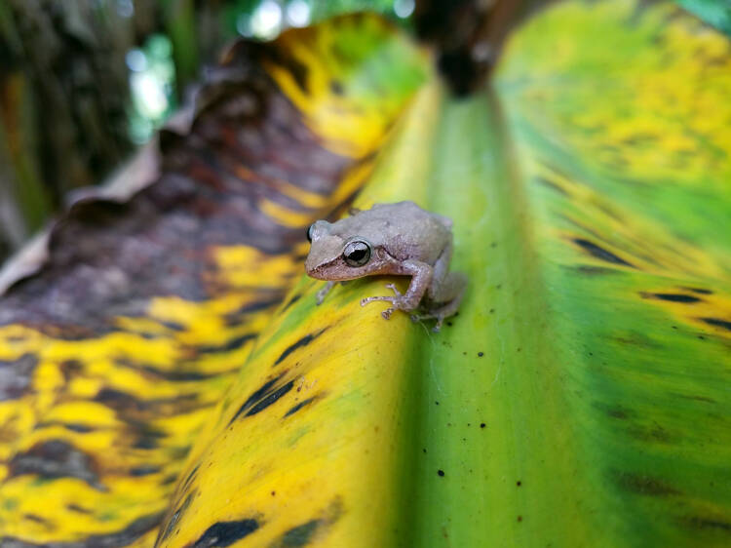**1. Coquí chorus**

**Where and when to experience it:** El Yunque National Forest, Puerto Rico; all year round

The only tropical rainforest in the US National Parks system is home to 13 of the 17 species of coquí, a small arboreal frog whose colors range from brown to yellow and green. As night falls, the frogs begin their enchanting two-note song. It’s hard to believe these tiny two-inch creatures can emit so much sound; they can be heard not just within the park itself (camping allowed by permit only), but through much of the surrounding towns and villages.

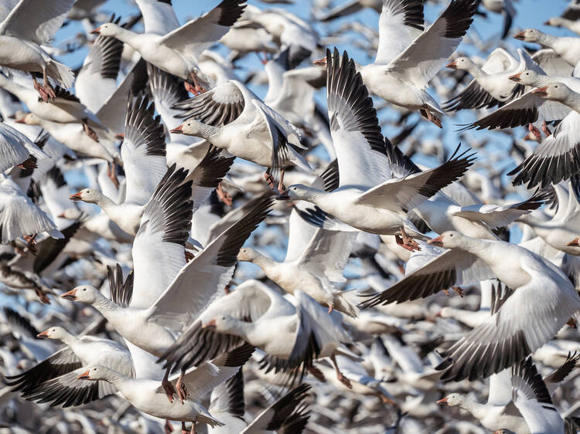**2. Snow goose migration**

**Where and when to experience it:** Cayuga Lake, New York; March

The Atlantic Flyway is one of four major bird migration routes in North America. In the spring, a variety of birds use this path to return to Northern locations from their wintering grounds in the Mid-Atlantic or South. Stand at the edge of Cayuga Lake in the Finger Lakes Region, and you’ll be treated to the site of hundreds of thousands of snow geese returning to the area. Observing the majestic pale birds soar overhead, the black tips of their wings just visible against the sky, is like watching a thick snow blanket over the lake.

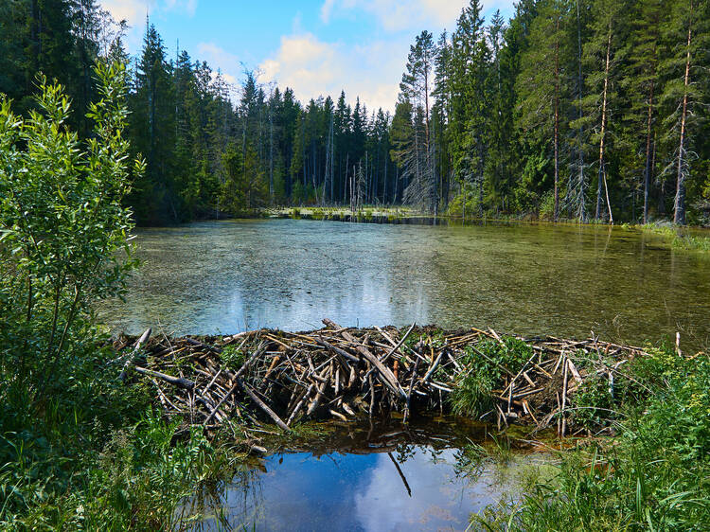**4. Beaver dam-building**

**Where and when to experience it:** [Pleasant Valley Wildlife Sanctuary](https://www.massaudubon.org/get-outdoors/wildlife-sanctuaries/pleasant-valley), Lenox, Massachusetts; spring

Often considered a nuisance animal in residential environments, beavers are a keystone species that are essential for promoting biodiversity. These 'ecosystem engineers' are best known for gnawing down trees and building dams and dens; dams can range from a few feet wide to around 300ft. These activities help thin forests and create wetlands, which attract an incredible variety of other mammals, fish, and insects.

Spring is breeding season, and also when two-year-old beavers leave their dens to create their own territories. The best time to watch these industrious critters at work is dusk or sunup.

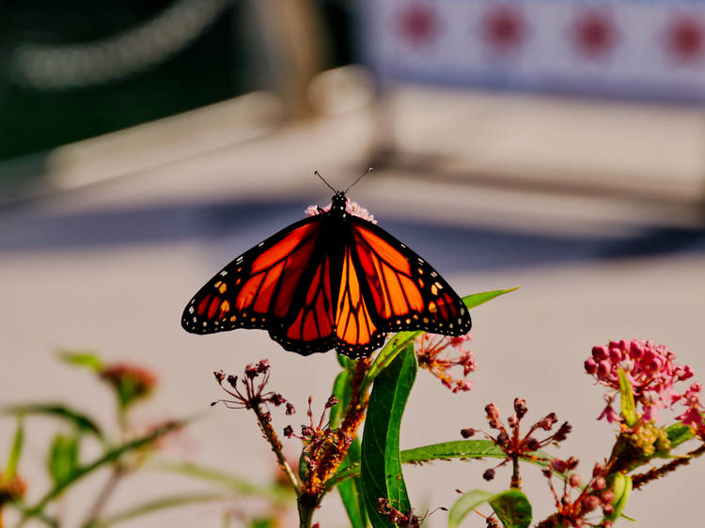

**5. Monarch butterfly migration**

**Where and when to see it:** Highway 1, Central Coast California; November through March

Late fall marks the mass movement of [monarch butterflies](https://www.worldwildlife.org/species/monarch-butterfly) from colder Western climates to the Central Coast of California. After a strangely silent 2020, the endangered insects were back in force in 2021, with researchers clocking as many as 230,000 butterflies in a single season at Pismo State Beach [Monarch Butterfly Nature Preserve](https://www.parks.ca.gov/?page_id=30273). The recently introduced Western Monarch Trail, along Highway 1, follows the migration route of these flashy insects, who alight along the coast for shelter, nectar to feed, and the native milkweed that provides food for their larvae. The trail is marked with signage that identifies crucial overwintering and feeding locations.

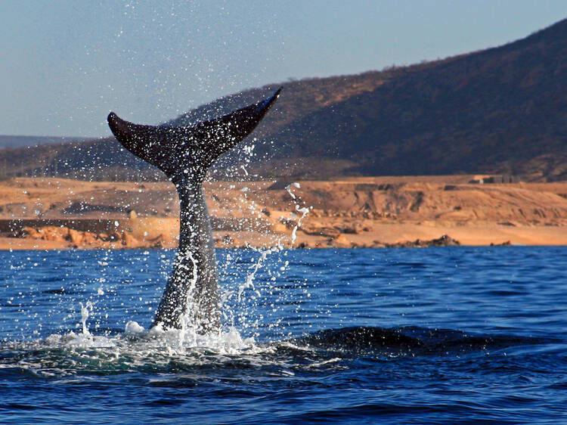**7. Whale migration**

**Where and when to see it:** Maui, Hawaii; November through May

From fall through early spring, thousands of North Pacific humpback whales glide through the waters around Maui for their annual winter migration. These spectacular creatures, which weigh 25 to 40 tons and produce songs that can be heard up to 12 miles away, make their way from Alaska to the deep, warm waters of Hawaii each year to mate and give birth.

Both the north and south coasts of Maui are excellent for observing the migration, but Maui Nui Basin, along the southwestern coast, is especially rich in viewing opportunities.

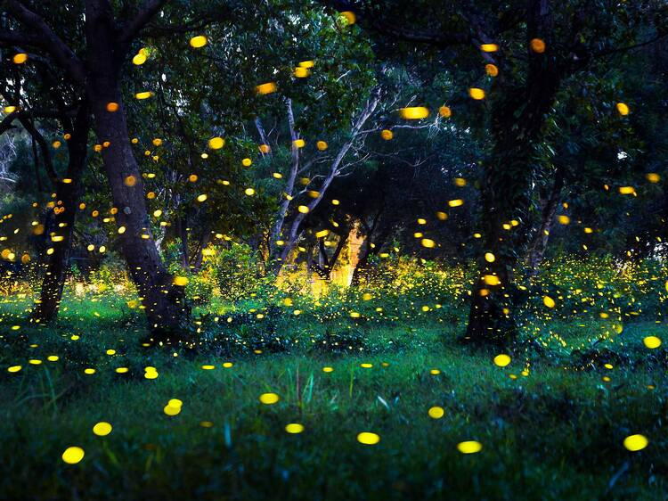**8. Firefly fireworks**

**Where and when to see it:** Great Smoky Mountains, Tennessee; mid-May to mid-June

More than 170 species of fireflies are abundant in the warm, humid environments of the eastern USA. But nowhere are their displays more impressive than in the [Great Smoky Mountains](https://www.nps.gov/grsm/index.htm) of east Tennessee. From mid to late spring, the forests are aglow with a magical green aura caused by [lightning bugs](https://en.wikipedia.org/wiki/Firefly). One species of firefly glows synchronously, or all at the same time. Others flash in alternating bursts. Take the firefly shuttle in the Great Smoky Mountains National Park for peak viewing.

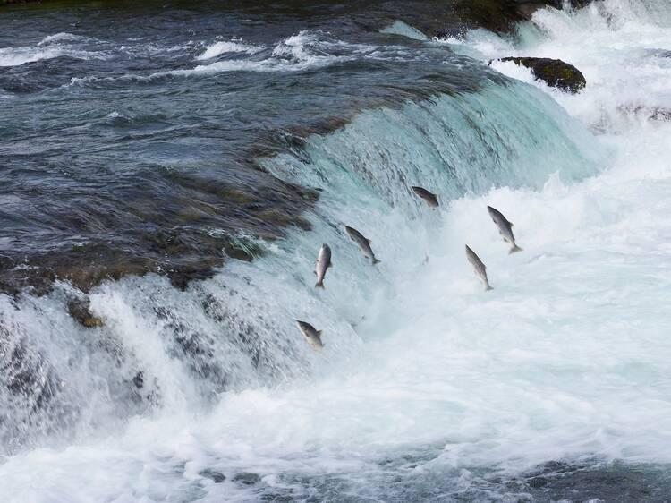**9. Jumping salmon**

**Where and when to see it:** Russian River Falls, Alaska; late June and late July

Early spring and midsummer are the best times to see thousands of red-bodied sockeye salmon leaping the stairstep falls of the Russian River in Alaska. Take the two-mile trail to the viewing decks, where you can watch the green-headed fish swim upstream, en route to their spawning grounds. (State fisheries managers maintain a fish ladder, a structure that allows migrating fish to pass over an obstacle, to ensure that enough salmon reaching their destination.) You might even catch sight of a brown bear wading through the river and snagging a salmon in its traplike jaws.

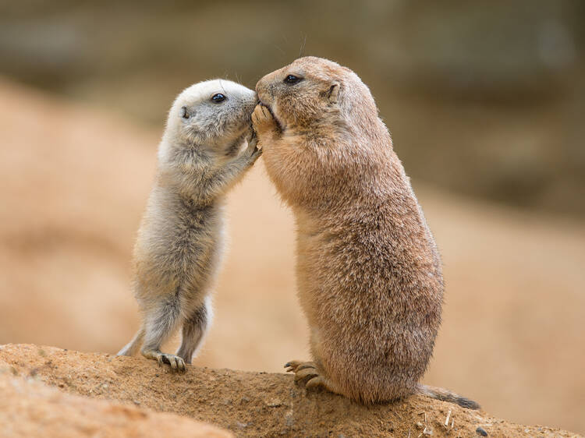**10. Kissing prairie dogs**

**Where and when to see it:** Roberts Prairie Dog Town, South Dakota; April through June

Humans might think they own the block on kissing, but prairie dogs have their own type of smooch. In order to greet and identify one another, they press their front teeth together to take in one another’s scent.

[Roberts Prairie Dog Town](https://www.nps.gov/places/roberts-prairie-dog-town.htm) is home to thousands of black-tailed prairie dogs. Part of the squirrel family, the prairie dogs weigh up to 3lbs and live in an underground network of 'towns.' They pop out frequently to have a look around, munch grass, or repair their burrows. Go during the day, when the sun is out, to catch them in a liplock.